
Ashleigh Lock
Head coach and owner of Bounce & Flex
Safeguard training and certificate in Sport (updated sept 2022)
bounceandflex@hotmail.com

07790892971

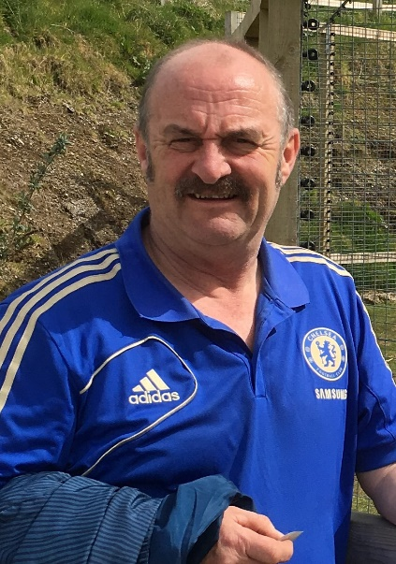
Bernie Lock
Joint head coach at Bounce & Flex
Safeguard training and certificate in Sport (updated sept 2022)
bvlock@btinternet.com
07761655185
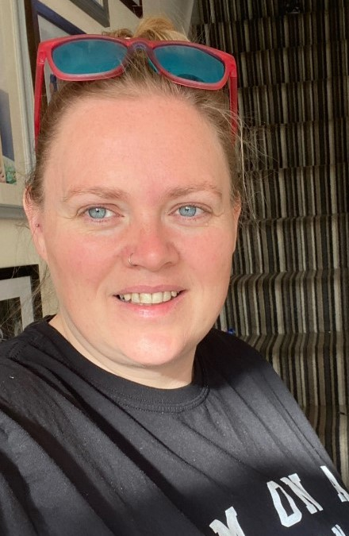
Kerry Broughton
Club safeguard and welfare officer
Designated safeguarding lead Certificate (updated dec 2021)
Safeguardbounceandflex@gmail.com
07968946673

If you have any concerns please fill out an incident report form on our website and email to Kerry broughton Or use the relevant numbers displayed

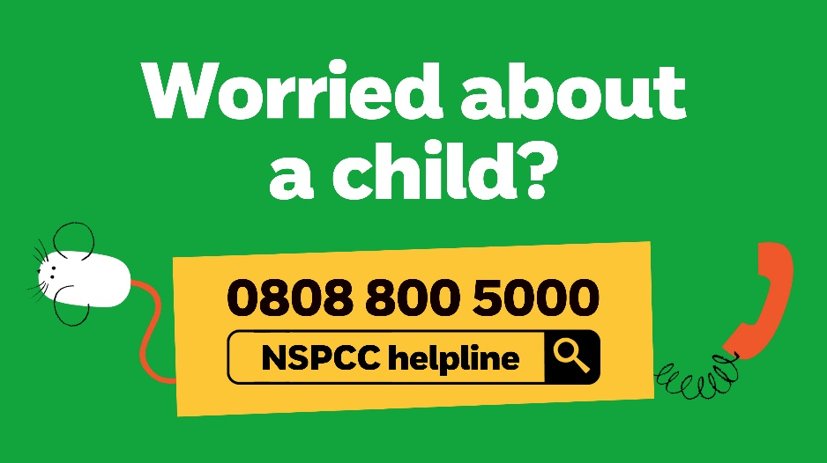


- If you’re worried about your child or something they’ve witnessed, talk to them and listen to any worries or concerns they might have. Try not to be dismissive, judgemental or blame anyone. Have an open mind.
- Don’t panic, however small or large the worries or concerns may be, someone is available to help you.

- If you’re unsure who to speak to, the NSPCC helpline can support you and advise you on what to do next - call 0808 800 5000.
- Every club should have procedures in place for dealing with concerns, and you can ask to see these. This will help you to follow the processes in place and feel confident to make a report.

- Speak to the club’s child protection, safeguarding or welfare officer and discuss your concern, ask what happens next and how your child will be supported going forward.
- Let your child know that you’ve acted on what they’ve told you and that they can come back to you again if they need to.
If you think a child is in immediate danger of abuse, contact the police on 999
The idea of speaking out about abuse or poor practice in a club can be daunting but the services above are designed to help you if you have any concerns at all.
Another useful number:
Children’s Social Care – childrens@somerset.gov.uk – 0300 123 2224

WORKING TOGETHER TO KEEP CHILDREN SAFE IN SPORT

